2022-2023
First Nations’ Emergency Services Society
and Indigenous Services Canada

NEW
Wildland Fire Equipment
Purchasing Program

The following is a complete streamlined document intended to function as the:

Program Guide
Expression of Interest
Application
Completion Documentation

Table of Contents
Program Overview 3
Program Outline 4
Step 1: Expression of Interest 5
Step 2: Application Form 7
Step 3: Final Report Form 11
Appendix A - Wildland Fire Equipment Recommended Kit Lists 14
Appendix B - Wildland Fire Equipment - Individual Items List 23
Appendix C - Wildland Fire Crew Types and Required Equipment Kits 27
Appendix D - Equipment Kit Pathways to Wildfire Contracts/Capacity 28

Program Overview
In recent years, wildland firefighter training has been administered by the First Nations’ Emergency Services Society (FNESS) on a first-come first-serve basis, with funding provided by the BC Wildfire Service (BCWS) and Indigenous Services Canada (ISC). The purchase of wildland firefighting equipment was often left out of funding programs or had been very limited in scope. In fall 2021, FNESS worked to better understand the long-term training needs for First Nations in BC. Through this process FNESS determined that providing more comprehensive training packages with sustainable funding was only half of the solution. To build successful Indigenous-led wildfire crews, there needed to be the ability to obtain the proper equipment. This equipment is crucial to cover mandatory safety requirements and the ability to respond/deploy to fires efficiently. This will in turn, build capacity, create employment opportunities, and retain skillsets/resources at the community level.
In response to this need FNESS is administering the Wildland Fire Equipment Purchasing Program to complement wildfire training/crew development, Nations’ Wildland Urban Interface (WUI) Fire Response Capability, and overall Wildfire Resiliency. Funding for this initiative is provided by ISC and is open until March 31, 2023 until funding is exhausted. This trial program allows for eligible core WUI firefighting equipment purchases to support wildland fire response and crew development. The initial funding will be prioritized for Nations who have high-extreme wildfire risk ratings. Upon successful administration of this trial, FNESS (with ISC approval) hopes to expand this service to lower risk Nations that meet the additional funding criteria.
Many Nations have also expressed a desire to gain wildfire experience and access to the various economic contract opportunities with BCWS. In response, this program compiles eligible wildfire equipment into recommended modular kits. The kit contents are described in Appendix A - Wildland Fire Equipment - Recommended Kit Lists and are designed to streamline equipment purchasing by describing the necessary equipment for different types of operational wildfire response. For example, the “Expanded Attack Equipment” kit provides enough hose and accessories to deliver water over 1 km of fireline. While it is recommended to purchase as complete kits, FNESS recognizes that different Nations have different equipment needs, personnel amounts, and varying landscapes. As a result, eligible individual item purchases are listed in Appendix B – Wildland Fire Equipment - Eligible Individual Items List. These kits can be combined in various ways to meet the equipment requirements of the various provincial government fire crew contracts as visualized in Appendix C - Wildland Fire Crew Types and Required Equipment Kits. In addition, Appendix D – Equipment Kit Pathways to Wildfire Contracts and Capacity, provides a variety of kit combinations and several recommended configurations to align with your community’s wildfire capacity needs.
The items within the kits are based on the recommendations of the FNESS Wildfire Specialists and are intended to provide Nations with equipment mirroring that are used by Type 1 wildfire crews in North America. The recommended retail prices included in the equipment guide and application are conservative in nature to try and account for variance in regional purchasing. We at FNESS understand that challenges in purchasing will undoubtably arise. As such, our Wildfire Specialists will work with Nations to ensure flexibility and that required grant parameters are achieved.
* Note FNESS does not guarantee the kits meet all contract requirements nor does the equipment provide an advantage in achieving a standing arrangement.

Program Outline

Grant Amount: Up to $75,000.00
Program Enrollment Timeline: December 9, 2022 - March 31, 2023 or until funding is exhausted
Eligibility: First Nation communities that:
- are rated as high to extreme wildfire risk rating.
- have or are scheduled to receive Wildland Firefighter Training (will provide supporting documentation to FNESS).
- actively involved (2020-present) in Community Resiliency Investment Program (CRI) or ISC On-reserve Operational Fuel Treatment, FireSmart, or Cultural and Prescribed Fire Programs.
Eligible Costs and Activities: Wildland Firefighting Equipment and Personal Protective Equipment (PPE) items that are described in Appendix A – Wildland Fire Equipment - Recommended Kits Lists or Appendix B – Wildland Fire Equipment Eligible Individual Items List.
Ineligible Costs: Any services or items that are not identified within the appendices and/or Excessive PPE purchases.
Payments: No purchases will be approved until written confirmation is provided by FNESS. Payment will be in the format of a full reimbursement through FNESS upon receiving scanned copies of approved purchases and checked off equipment kit lists. Requests for partial or progressive payments will not be accepted.

Process:
Step 1: Fill out the Expression of Interest and submit to FNESS
FNESS will review and follow up with any missed components, advise if the grant criteria are met, and instruct applicant to proceed to Step 2 or provide guidance to qualify for future intakes.
Step 2: Fill out an application and submit to FNESS
(If advised by FNESS that the Expression of Interest meets eligibility.)
FNESS will review the application and return with signed approval letter to proceed with the purchases listed.
After receiving a signed Application Approval Letter from FNESS, purchase the goods outlined in your application.
If challenges are encountered in purchasing the items identified from the approved and signed application, then the applicant must contact FNESS Wildfire Specialists for assistance.
All goods must be purchased within 11 months of approval.
*Invoices and receipts must be retained as proof of purchase*
Step 3: Return final reporting form with scanned invoices and receipts for review by FNESS
FNESS will re-imburse applicant for all completed purchases that were identified on the approved application and accompanied with scanned invoices and receipts.
Final Reporting must be submitted within 12 months of approval.

Step 1: Expression of Interest

FNESS is seeking an expression of interest from all First Nation communities to engage with FNESS to determine your wildland firefighting equipment needs.

The submission of this document represents Step 1 in FNESS’ Wildland Firefighting Equipment Purchasing Pilot Program. This information will help to ensure that communities meet the eligibility requirements put forward by ISC for the pilot program (December 9, 2022- March 31, 2023) and provides valuable insight into communities’ needs for expansion of this program in future years. Successful candidates will be awarded up to $75,000.00 to outfit their communities with adequate Wildland Fire Suppression equipment.

Please ensure that the contact information below is correct and answer the questions on the next page to the best of your ability. If you answer yes to questions 2-4, please submit proof of participation with this expression of interest.

Contact Information
Community Name:
Community Contact Person:
Community Physical Address:
Community Mailing Address:
Phone Number:
Email:

- Is your community located in an area of high or extreme wildfire risk rating?
☐ Yes ☐ No
Please elaborate below:

- Has your community been involved in the Community Resiliency Investment Program (CRI) or Indigenous Services Canada (ISC) On-reserve Operational Fuel Treatment, FireSmart, or Cultural and Prescribed Fire Programs in the past two years (2020- present)?
☐ Yes ☐ No
Please state year and type of involvement below:

- Has your community participated or enrolled in the FNESS wildfire training program (can provide documentation)?
☐ Yes ☐ No
If yes, please state course dates, instructor name, and number of trained people below:

- Has your community engaged in S-course wildfire training with BCWS (can provide documentation)?
☐ Yes ☐ No
If yes, please state course dates, instructor name, and number of people trained below:

- Does your community currently have (or has previously had) a contracted wildfire suppression crew (Entry-level Fire Services, Type2/3, Indigenous Initial Attack) registered with BCWS?
☐ Yes ☐ No
If yes, please state crew type and number of trained crew people below:

- What is your community’s primary fire equipment need (e.g., PPE, fire suppression crew development, community wildfire response capacity)?
Please state below:

Kukwstsétsemc, we look forward to hearing from you.

Please return this expression of interest to:
Karen Alexandre – Mitigation Administrative Coordinator
Email: kalexandre@fness.bc.ca | Cell: 250-320-4680 or BC Toll Free: 1-888-388-4431

Step 2: Application Form

*Complete this application form only after receiving confirmation from FNESS*
Please type directly in this form or print and complete. Additional space or pages may be used as required.
APPLICANT INFORMATION
Community Name: | Community Location:
Applicants Contact Name: | Applicants Contact Email Address:
Applicants Contact Phone: | Contact E-mail:
Community Wildfire Representatives Name: | Community Wildfire Representative Phone:
Primary Objective of Grant Expenditure: Check the following option that best meets your community’s needs.
☐ Obtain Basic Complement and PPE for the benefit of the greatest number of community members.
☐ Obtain Basic Complement and PPE for fewer members and introductory wildfire suppression equipment.
☐ Obtain Basic Complement and PPE for a small, focused crew with more advanced wildfire suppression equipment.
☐ Replace and or improve some our existing wildfire equipment.
☐ Add capacity with larger items such as high-pressure pumps, holding tanks, etc.
☐ Our needs vary and are a mix of the above mentioned.
Date: Click or tap to enter a date.
Signature:
Comments Optional:
Supporting Documents to attach (if not submitted with EOI):
☐ Proof of training
☐ Proof of CRI/ISC involvement (2020-present)
☐ First Nation Band Council Resolution

Please fill in the table below with the number and cost of kits that you would like to purchase.
All kit breakdowns can be found in Appendix A – Wildland Fire Equipment - Recommended Kit List.
* PPE complement being purchased should be reflective of the number of trained community members.
TABLE A: WILDLAND FIRE EQUIPMENT KITS REQUESTED
Equipment Kit | Cost Budget | Quantity | Subtotal
Basic Complement/PPE | $1,795.00
5-Person Type 3 Crew Equipment | $7,010.00
4-Person Type 2/IIA Crew Equipment | $8,010.00
Power Saw Operator/Faller Kit | $2,988.00
Initial Attack Pump Kit | $7,052.00
Sustained Action Pumping Kit | $15,157.00
Expanded Attack Equipment | $15,055.00
 |  | A. Total

* If no additional items are needed proceed to Page 9 and record your subtotal.

Please fill in the table below with any individual items you would like in addition to the kits.
All items and estimated prices can be found in
Appendix B –Wildland Fire Equipment - Eligible Individual Items List.

TABLE B: WILDLAND FIRE EQUIPMENT INDIVIDUAL ITEMS REQUESTED
Item Description | Cost Budget | Quantity | Subtotal
 |  |  | $
 |  |  | $
 |  |  | $
 |  |  | $
 |  |  | $
 |  |  | $
 |  |  | $
 |  |  | $
 |  |  | $
 |  |  | $
 |  |  | $
 |  |  | $
 |  |  | $
 |  |  | $
 |  |  | $
 |  |  | $
 |  |  | $
 |  |  | $
 |  |  | $
 |  |  | $
 |  |  | $
 |  |  | $
 |  |  | $
 |  |  | $
 |  |  | $
 |  |  | $
 |  |  | $
 |  |  | $
 |  |  | $
 |  |  | $
 |  |  | $
 |  |  | $
 |  | B. Total | $
Please calculate the totals of Table A and B below and submit to the Band Council for approval.

Total Amount of Fire Equipment Kits and Individual Items
Table A Total: $ | Table B Total: $
Grand Total must be less than $75,000.00 | GRAND TOTAL: $
Authorized Band Council Signature
I certify that the above purchase proposal is consistent with our community’s training and needs for wildfire suppression.
Band Authorized Signatory Name: |  | Signatory’s Position:
 |  | Date: Click or tap to enter a date.
Band Councils Scanned Resolution Attached: ☐ Yes ☐ No
Comments Optional:
First Nations Emergency Services Society Representative (section to be filled out by FNESS)
FNESS Staff Name: |  | FNESS Staff Name:
FNESS Application Approval Signature: |  | FNESS Application Approval Signature:
Application Status: ☐ Approved ☐ Needs Amendments ☐ Not Yet Available During This Uptake
Comments:
After signatures have been attained from authorized signatories, please return this document as well as a scanned band council resolution to the email address below.
Applications will be received starting on December 9, 2022 and will be accepted on a first come, first serve basis until funding is exhausted.
Mitigation Department, First Nations’ Emergency Services Society
E-mail: kalexandre@fness.bc.ca Address: A274 Halston Road, Kamloops, BC, V2H 1P7

Step 3: Final Report Form

FNESS - ISC Wildfire Equipment Purchasing Program is managed by FNESS. Grant administration is provided by FNESS with provision of funding by ISC. The initiative supports First Nation communities who demonstrate commitment to wildfire mitigation and response through wildland firefighter training and fuels management initiatives.
Please type directly in this form or print and complete. Additional space or pages may be used as required.
SECTION 1: APPLICANT INFORMATION
Community Name:  Business name (if applicable): | Date of Application: Click or tap to enter a date.
Primary Contact: | Contact Address:
Contact Phone: | Contact E-mail:
SECTION 2: PROJECT INFORMATION
- Total applicant cost applied for, not to exceed $75,000.00.
- Equipment Purchased and Detailed Invoices Attached?
☐ Yes ☐ No Final Purchase Date:

SECTION 3: INVOICED PURCHASES FOR FUNDING FROM APPROVED BUDGET
Description of Invoice  (e.g., Mark 3 pump, 20 x 1 ½” hose, power saw operator kit, etc.) | Amount ($)
 | $
 | $
 | $
 | $
 | $
 | $
 | $
 | $
 | $
 | $
 | $
 | $
 | $
 | $
Total Expenditure | $

Total Funding Requested |  | $
Total Eligible Grant |  | $75,000.00
Bands are responsible for proper fiscal management, including maintaining acceptable accounting records for the project. FNESS and/or the funder (Canada) reserve the right to audit these records.
SECTION 4: CERTIFICATION OF COSTS (to be signed by Chief Financial Officer)
I certify that the costs stated above: (1) have been incurred and paid; (2) are attributable to the program; (3) are eligible as per the approved budget sent with your approval letter; and (4) are net of tax rebates and any other rebates.
Name: | Title:
Signature: | Date: Click or tap to enter a date.

Appendix A - Wildland Fire Equipment Recommended Kit Lists

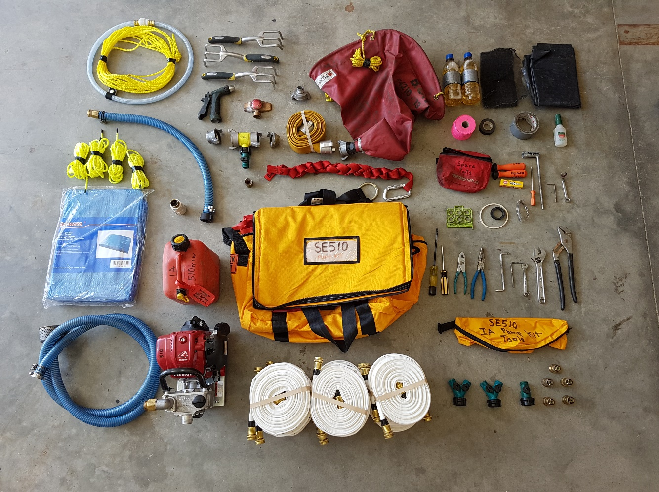

The following lists compile fire equipment into kits that are designed to be progressively combined to develop increasing operational wildfire response capability while simultaneously satisfying equipment requirements of the various contract crew standing arrangements with BC Wildfire Service. Each list features a blank column which can be used as a checklist or a way to track actual expenditures to assist with staying within approved budgets.

Table of Contents
Basic Complement/PPE - per person 16
5-Person Type 3 Crew Equipment 17
4-Person Type 2 and Indigenous Initial Attack Crew Equipment. 18
Power Saw Operator/Faller Kit 19
Initial Attack Pump Kit 20
Sustained Action Pumping Kit 21
Expanded Attack Equipment 22

Basic Complement/PPE per person
The following list meets/exceeds requirements of Entry Level Fire Services and satisfies the personal gear/PPE requirements of TYPE 3, 2 Contracts Crews including BCWS Type 1.

Hard Hat – CSA/ANSI approved, orange, must accept snap on attachments | $ 32.00
Chin Strap – with or without chin cup | $ 14.00
Hearing Protection – Peltors, attaches to hard hat, recommend 105 db rating | $ 72.00
Face Screen – metal mesh, attaches to hardhat and flips up and down | $ 31.00
Safety Glasses - CSA or ANSI approved, recommend tinted or clear | $ 20.00
Headlamp – LED, prefer disposable AA’s or AAA’s versus re-chargeable | $ 40.00
Personal First Aid Kit –CSA Type 1 for belts, must have 4” Compression | $ 67.00
Work Gloves – Non-synthetic, leather, Roper or Mechanic Style | $ 15.00
Work Boots – All leather and 8” tall, mountaineering or logging style | $ 490.00
Nomex Shirt – CAN/CGSB 155.22-2014 or NFPA 1977 – not Red | $ 137.00
Nomex Pants - CAN/CGSB 155.22-2014 or NFPA 1977 – not Red | $ 226.00
Hi-Vis Safety Vest - (or Hi-vis on Nomex) - When Around Heavy Equipment | $ 36.00
Mask – Ash/Dust, N95 disposable with valve and/or Respro Bandit Scarf | $ 21.00
Whistle – Fox 40 style or similar | $ 11.00
Leather Belt – 2” Leather - Kuny style or similar | $ 28.00
Backpack- Daypack for Fireline Use – with food and water for a day’s work | $ 450.00
Firefighting Hand Tool- Pulaski/Shovel/and Fire Rakes (light fuel types) | $ 150.00
4-Person Crew = $7,180.00 5-Person Crew = $ 8,975.00 Total: per person | $ 1,795.00
- Type 2 Crew Contract requires two complete sets of Nomex clothing.
- The Nomex Shirt/Pant standard can also be met by using fire resistant coveralls.
- When buying firefighting hand tools, the Pulaski is preferred, however purchase an assortment, for example if buying for 5 people recommend- 3 x Pulaskis, 1 x Shovels and 1 x Fire Rake.

5-Person Type 3 Crew Equipment
The following list meets the crew equipment requirements of TYPE 3- 5 Person Contract Crews.

2 x Handheld Radios – Programed with BCWS simplex/duplex/RR | $ 330.00 x 2
1 x Handheld GPS - Global Positioning System, AA batteries | $ 280.00
1 x Compass – Navigation, handheld | $ 95.00
5 x Overnight Backpack – recommend Sealine Dry Bag Backpack | $ 240.00 x 5
5 x Sleeping Arrangements – recommend 1 - person tents | $ 310.00 x 5
5 x Sleeping Bag – rated for spring, summer and fall (3 - season) | $ 260.00 x 5
5 x Sleeping Mat – recommend self-inflating | $ 130.00 x 5
2 x Backpack Hand Pumps- collapsible or rigid plastic/metal | $ 270.00 x 2
2 x Drip Torches – 1 Gal, aluminum, D.O.T. approved | $ 275.00 x 2
1 x Level 1 First Aid Kit – Worksafe, recommend stored in dry bag | $ 155.00
2 x Rolls Flagging Tape - Orange, Green, Pink, Blue DTA, NWZ | $ 10.00
Spare batteries for GPS and Headlamps | $ 20.00
Total: | $ 7,010.00

- Compass and Handheld GPS are standalone items as per the requirements and cannot be combined or substituted with a smart phone feature.
- Backpack Hand Pumps are most often preferred in rigid plastic.
- Handheld Radios do not come programmed with the required channels therefore programing is an additional requirement and cost.
- Sleeping mats are not required to be self-inflating however space can be limited therefore self-inflating or compact solid foam are preferred over thick foamies.
- Sleeping arrangement configurations are not defined so combined multi person tents are acceptable however single tents are recommended for health, quality of sleep and operational flexibility.

4-Person Type 2
and Indigenous Initial Attack Crew Equipment
The following list meets the requirements of TYPE 2 - 4 Person Contracts Crews and Indigenous IA however the Type 2 Contracts are intended to be 8-person so double this list if that is your target.

4 x Handheld Radios – Programed with BCWS simplex/duplex/RR’s | $ 330.00 x 4
4 x Handheld GPS - Global Positioning System – AA batteries | $ 280.00 x 4
4 x Compass – navigation, handheld | $ 95.00 x 4
4 x Overnight Backpack or Duffle Bag – recommend backpack | $ 240.00 x 4
4 x Sleeping Arrangements – recommend 1 person tents | $ 310.00 x 4
4 x Sleeping Bag – rated for spring, summer and fall (3-season) | $ 260.00 x 4
4 x Sleeping Mat – recommend self-inflating | $ 130.00 x 4
2 x Backpack Hand Pumps- collapsible or rigid plastic/metal | $ 270.00 x 2
2 x Drip Torches - 1 Gal, aluminum, D.O.T. approved | $ 275.00 x 2
1 x Level 3 First Aid Kit – recommend backpack style | $ 310.00
2 x Rolls Flagging Tape, Orange, Green, Pink, Blue DTA, NWZ | $ 10.00
Spare batteries for GPS and Headlamps | $ 20.00
Total: | $ 8,010.00

- Compass and the Handheld GPS are standalone items as per the requirements and cannot be combined or substituted with a smart phone feature.
- Backpack Hand Pumps are most often preferred in rigid plastic.
- Handheld Radios do not come programmed with the required channels therefore programing is an additional requirement and cost.
- Additionally, contracts for Type 2 8-Packs and Indigenous IA 4-Packs also require a Satellite Phone with active subscription.
- Sleeping mats are not required to be self-inflating however space can be limited therefore self-inflating or compact solid foam are preferred over thick foamies.
- Sleeping arrangement configurations are not defined so combined multi person tents are acceptable however single tents are recommended for health, quality of sleep and operational flexibility.
Power Saw Operator/Faller Kit
The following list meets the requirements of a Power Saw Operator and Danger Tree Faller with the exception that the Danger Tree Faller requires a second chainsaw as a spare. For simplicity it is recommended to have a second complete saw kit to satisfy the Danger Tree Faller Requirements which would/could also act as a second Power Saw Operator Kit.

1 x Chainsaw – 60cc and 24” Bar (minimum), full wrap handlebar | $ 1840.00
1 x Spare Bar 24” (minimum) – must match saw brand | $ 110.00
1 x Spare Chain – must fit bar length and saw brand | $ 50.00
1 x Spare Spark Plug – must be correct model for saw | $ 11.00
1 x Bucking Chaps or Fallers Pants – 3600 tcs (minimum) | $ 200.00
1 x Bucker/Fallers Belt – recommend 2” leather belt | $ 28.00
1 x Falling/Bucking Axe - pinned 3½ lbs. head, 17” handle (minimum) | $ 52.00
1 x Belt Axe Holder – Weaver axe holder or Kuny hammer loop | $ 84.00
1 x Belt Wedge Pouch | $ 32.00
3 x Bucking and Falling Wedges | $ 10.00 x 3
1 x .225 kg Dry Powder Extinguisher - in belt holder case | $ 98.00
1 x Combi Can – bar oil and 50:1 saw gas | $ 29.00
1 x Set of Saw Tools – Bar Wrench and Tuning Driver | $ 12.00
Round Saw Files, Flat Raker Files, Sharpies or Lumber Crayon | $ 75.00
1 x Saw Kit Bag – not required but recommended | $ 337.00
Total: | $ 2,988.00
- PSO’s and Fallers also require hearing, face protection, whistle, compression bandage, high vis which is included in the Basic Firefighters Equipment Complement.
- Falling and bucking wedges get worn out, so it is beneficial to have extra.
- Chainsaws must have spark arrestors and all safety features must be working.
- Fallers and PSO often carry additional items such as spare bars nuts, screws, parts, air filters, fuel filters, tree marking paint, rakers gauges, roller saw file guides, tape measures, line levels, extra chain, etc. however these are not identified in the contracts.

Initial Attack Pump Kit
The following list makes up the core components of BCWS’s Type 1 Initial Attack Crew Pump Kits.

Initial Attack Pump – 1½” intake, >50psi, 50gpm, 50cc/2hp  Waterax Mini-Striker or Wick 100-4H or Honda WX15 | $ 1750.00
Suction Hose - 1½”, non-collapsible, approx. 6’- 8’ long | $ 97.00
Foot Valve –1½” or 2” with a 1½” adapter | $ 187.00
Fuel Can – 1 gal – full of straight gas | $ 34.00
2 x Water Thief - 1½” Forestry Quick Connects, 5/8th Shut Off | $ 41.00 x 2
1 x Male Reducer - 1½” Forestry Quick Connect to Male 5/8th | $ 10.00
1 x Female Reducer - 1½” Forestry Quick Connect Female 5/8th | $ 16.00 x 2
2 x 1½” Forestry Quick Connects to Female 1½” NPSH Thread | $ 9.00 x 2
1 x 1½” Fog Nozzle | $ 36.00
15 x 5/8th Econo Hose (3/4” also acceptable) | $ 77.00 x 15
2 x 5/8th 3-Ways (also called Econo Wyes) | $ 6.00 x 2
4 x 5/8th Econo Nozzles | $ 12.00 x 4
1 x Pump/Hose Wrench – also referred to as Spanner Wrench | $ 18.00
1 x Tarp – Approx 6’ x 9’ | $ 18.00
1 x 4” to 1½” Relay Tank PVC Ball Valve | $ 45.00
10 x 100ft 1” Fire Hose - Forestry Quick Couple Ends | $ 190.00 x 10
1 x 500 Gallon Relay Tank- collapsible also called Porta Tank | $ 1270.00
Spare Parts – Spark Plug,1½ and 5/8th Gaskets, Wire, Mesh Screen, 2 x 1 ¾” Hose Clamps, 250ml 10w-30 Oil | $ 50.00
Tools – Spark Plug Wrench, Crescent Wrench, Needle Nose Plyers, Multi-Bit Screwdriver, 10mm Wrench | $ 25.00
1 x IA Pump Kit Bag - not required but recommended | $ 265.00
Total: | $ 7,052.00

- This kit is the core component of a BCWS Initial Attack Heli-Tack Kit however this type of kit also accompanies Initial Attack Crews in pick-up trucks and Initial Attack Type 5 Wildfire Engines. It is quick and easy to deploy for initial attacking small new wildfires that breakout. Due to its lightweight and portability it is also the go to pump for easy pumper truck refilling and even expanded attack operations for portable mop-up and patrol along with kicker pump applications.

Sustained Action Pumping Kit
The following list adds Initial Attack response capacity and when paired with the IA Pumping Kit it makes up the major component of a Type 5 IA Truck. This pump and equipment are the same equipment utilized on large project wildfires. This kit will approximately wrap a 1-hectare fire or cover 0.5 km of fireline.

High Pressure Pump- 2” Intake, >275psi, 100gpm, 185cc/10hpp Waterax Mark 3 or Mercedes Wick 375 | $ 5,600.00
1 x Suction Hose – 2”, non-collapsible, approx. 8ft -10ft Long | $ 165.00
1 x Foot Valve – 2” | $ 187.00
2 x Fuel Can – 5 Gallon - full 50:1 gas | $ 34.00 x 2
3 x Fuel Line – Mercury pump fuel fitting to fuel can cap | $ 104.00 x 3
2 x Pump/Hose Wrench – also called spanner wrench | $ 18.00 x 2
2 x 10ft 1½” High Pressure Hose - Quick Connect Ends | $ 77.00 x 2
4 x 1½” 3 - Ways | $ 117.00 x 4
2 x 1½” Back Check Valves | $ 242.00 x 2
15 x 100ft 1½” Hose – With Forestry Quick Connect Ends | $ 245.00 x 15
2 x 1½” Fog Nozzles | $ 36.00 x 2
2 x 1½” Hansen Nozzles | $ 160.00 x 2
10 x 1½” Water Thieves with 5/8th shut offs | $ 41.00 x 10
10 x 5/8th Econo Hose | $ 77.00 x 10
5 x 5/8th Econo Nozzles | $ 12.00 x 5
5 x 5/8th Econo 3-Ways (also called Wyes) | $ 6.00 x 5
2 x Hose Strangler | $ 161.00 x 2
1500 Gallon Relay Tank – Collapsible – also called Porta Tank | $ 1820.00
1 x 3” to 1½” Forestry Quick Couple Relay Tank PVC Ball Valve | $ 65.00
1 x Tandem Adapter 2” Female NPSH to 1½ Quick Connect | $ 82.00
Pump Tools – spark plug wrench, multi-bit screwdriver | $ 25.00
Spare Parts – spark plugs x 3, extra 2-stroke mix oil | $ 32.00
Total: | $ 15,157.00

- The high-pressure pump, suction hose (with foot valve attached), and fuel can (with fuel line) are the core component of the kit and additional set-ups are often stocked to provide spares and tandem/parallel pumping capability.
Expanded Attack Equipment
The following list adds capacity to respond to larger incidents supported by more personnel while also expanding into Cultural and Prescribed fire capability. This kit will generally wrap a 4-hectare fire or cover 1 km of fireline on a project fire. This kit also represents half of the hose lay components of a TYPE 1 BCWS 20-person Unit Crew.
Note: Add Sustained Initial Attack Pumping Kits and PSO/ Faller Chainsaw Kits as required.

1 x 2500 Gallon Relay Tank – also called Porta Tanks | $ 2,805.00
30 x 100ft 1½” Fire Hose - with Forestry Quick Connects | $ 245.00 x 30
10 x 1½’” Water Thieves- with 5/8th Shut Offs | $ 41.00 x 10
4 x 1½” 3-Ways | $ 117.00 x 4
2 x 1½” Hansen Nozzles | $ 160.00 x 2
20 x 5/8th Econo Hose | $ 77.00 x 20
12 x 5/8th Sprinklers - 4ft tall with ½” rotating impact head | $ 95.00 x 12
2 x Hose Strangler | $161 x 2
1 x Class A Firefighting Foam – 5 Gal | $ 170.00
2 x Fire Rakes | $ 70.00 x 2
2 x Mcloud Rakes | $ 195.00 x 2
Total: | $ 15,055.00

- These are larger volume, additional quantities, and some more specialized equipment. As wildfire incidents expand in size this list would multiply. In addition, individual components of this list can all be purchased to action expanded attack fire. For example, in order to support larger fires that have longer fire perimeters just increasing quantities of 1½ fire hose would be appropriate.
- Additionally or alternately one could purchase individual items off the individual items list.

Appendix B - Wildland Fire Equipment - Individual Items List

The following list represents individual wildland fire equipment items that are eligible under the Wildland Fire Equipment Purchasing Program. They are intended to supplement the Wildland Fire Equipment Kit Lists if required or as standalone items to complement a community’s existing wildfire equipment. The addition of these items would be recorded in Step 2: Application Form under
Table B, and the total cost of all individual items from this list would be recorded in Table B Total. This list can also be used as a checklist as it features a blank column which could assist with tracking costs and staying within approved budgets.

Wildland Fire Equipment Individual Items
 | Cost Budget
High Pressure Pump- 2” Intake, >275psi, 100gpm, 185cc/10hp  Waterax Mark 3 or Mercedes Wick 375 | $ 5600.00
Initial Attack Pump – 1½” intake, >50psi, 50gpm, 50cc/2hp  Waterax Mini-Striker or Wick 100-4H or Honda WX15 | $ 1750.00
Suction Hose – 2”, non-collapsible, approx. 8ft -10ft long | $ 165.00
Suction Hose - 1½”, non-collapsible, approx. 6’- 8’ long | $ 97.00
Foot Valve –1½” | $ 187.00
Foot Valve – 2” | $ 187.00
Tandem Adapter 2” Female NPSH to 1½ Forestry Quick Connect Coupling | $ 82.00
Fuel Can – 1 gal – full of straight gas | $ 34.00
Fuel Can – 5 Gallon - full 50:1 gas | $ 34.00
Fuel Line – Mercury pump fuel fitting to fuel can cap | $ 104.00
2500 Gallon Relay Tank – also called Porta Tanks | $ 2805.00
1500 Gallon Relay Tank – Collapsible – also called Porta Tank | $ 1820.00
500 Gallon Relay Tank- collapsible also called Porta Tank | $ 1270.00
3” to 1½” Forestry Quick Connect Coupling - Relay Tank PVC Ball Valve | $ 65.00
100ft 1½” Hose – With Forestry Quick Connect Coupling Ends | $ 245.00
100ft 1” Fire Hose - Forestry Quick Connect Coupling Ends | $ 190.00
1½” Fog Nozzles | $ 36.00
1½” Hansen Nozzles | $ 160.00
1½” Water Thieves with 5/8th shut offs | $ 41.00
1½” Back Check Valves | $ 242.00
1½” 3-Ways | $ 117.00
1½” Male Reducer - Forestry Quick Connect to Male 5/8th | $ 10.00
1½” Female Reducer - Forestry Quick Connect Female 5/8th | $ 16.00
5/8th Econo Nozzles | $ 12.00
5/8th Econo 3-Ways (also called Wyes) | $ 6.00
5/8th Sprinklers - 4ft tall with ½” rotating impact head | $ 95.00
Pump Tools – spark plug wrench, multi-bit screwdriver | $ 25.00
Spare Parts – spark plugs x 3, extra 2-stroke mix oil | $ 32.00
Hose Strangler | $161.00
Class A Firefighting Foam – 5 Gal | $ 170.00
Pulaski | $130.00
Fire Rake | $ 70.00
Mcloud Rake | $ 195.00
Drip Torches - 1 Gal, aluminum, D.O.T. approved | $ 275.00
Chainsaw – 60cc and 24” Bar (minimum), full wrap handlebar | $ 1840.00
Spare Bar 24” (minimum) – must match saw brand | $ 110.00
Spare Chain – must fit bar length and saw brand | $ 50.00
Spare Spark Plug – must be correct model for saw | $ 11.00
Bucking Chaps or Fallers Pants - 3600tcs (minimum) | $ 200.00
Bucker/Fallers Belt – recommend 2” leather belt | $ 28.00
Falling/Bucking Axe - pinned 3½ lbs. head, 17” handle (minimum) | $ 52.00
Belt Axe Holder – Weaver axe holder or Kuny hammer loop | $ 84.00
Belt Wedge Pouch | $ 32.00
Bucking and Falling Wedges | $ 10.00
0.225kg Dry Powder Extinguisher - in belt holder case | $ 98.00
Combi Can – bar oil and 50:1 saw gas | $ 29.00
Set of Saw Tools – Bar Wrench and Tuning Driver | $ 12.00
Round Saw Files, Flat Raker Files, Sharpies or Lumber Crayon | $ 75.00
Chainsaw Kit Bag | $ 337.00
Hard Hat – CSA/ANSI approved, orange, must accept snap on attachments | $ 32.00
Chin Strap – with or without chin cup | $ 14.00
Hearing Protection – Peltors, attaches to hard hat, recommend 105db rating | $ 72.00
Face Screen – Metal mesh, attaches to hardhat and flips up and down | $ 31.00
Safety Glasses - CSA or ANSI approved, recommend tinted or clear | $ 20.00
Headlamp – LED, prefer disposable AA’s or AAA’s vs re-chargeable | $ 40.00
Personal First Aid Kit – CSA Type 1 for belts, must have 4” Compression | $ 67.00
Work Gloves – Non-synthetic, leather, Roper or Mechanic Style | $ 15.00
Work Boots – All leather and 8” tall, mountaineering or logging style | $ 490.00
Nomex Shirt – CAN/CGSB 155.22-2014 or NFPA 1977 – not Red | $ 137.00
Nomex Pants - CAN/CGSB 155.22-2014 or NFPA 1977 – not Red | $ 226.00
Hi-Vis Safety Vest - (or Hi-vis on Nomex) - When Around Heavy Equipment | $ 36.00
Mask – Ash/Dust, N95 disposable with valve and/or Respro Bandit Scarf | $ 21.00
Whistle – Fox 40 style or similar | $ 11.00
Leather Belt – 2” Leather - Kuny style or similar | $ 28.00
Backpack- Daypack for Fireline Use – with food and water for a day’s work | $ 450.00
Level 1 First Aid Kit – Worksafe, recommend stored in dry bag | $ 155.00
Handheld Radios – Programed with BCWS simplex/duplex/RR’s | $ 330.00
Handheld GPS - Global Positioning System – AA batteries | $ 280.00
Compass – navigation, handheld | $ 95.00
Overnight Backpack or Duffle Bag – recommend backpack | $ 240.00
Sleeping Arrangements – recommend 1 person tents | $ 310.00
Sleeping Bag – rated for spring, summer and fall (3-season) | $ 260.00
Sleeping Mat – recommend self-inflating | $ 130.00
Backpack Hand Pumps- collapsible or rigid plastic/metal | $ 270.00
2 x Rolls Flagging Tape, Orange, Green, Pink, Blue DTA, NWZ | $ 10.00
Spare batteries for GPS and Headlamps | $ 20.00

Appendix C - Wildland Fire Crew Types and Required Equipment Kits
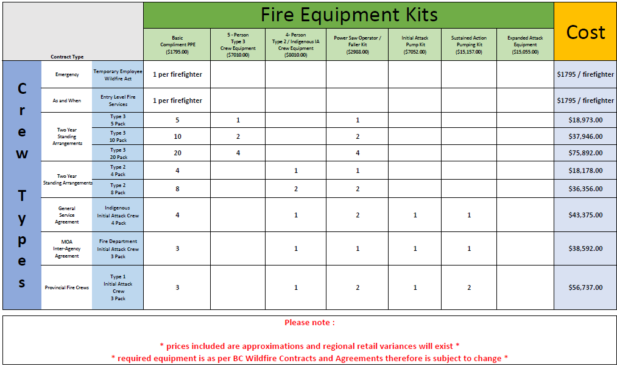

Appendix D - Equipment Kit Pathways to Wildfire Contracts/Capacity
